

Jeanne St.John, Ph.D.



Request for
Exception to Blue Cross Policy re
Total Ankle Replacement

Jeanne St.John, Ph.D.

September 12, 2006

Ms. Sheri Yuckert, Grievance Coordinator
Regence Blue Cross/Blue Shield of Oregon
PO Box 1271
Portland, OR 97207-1271

Re: 092000328 YVP 920658346
Regence BCBS of Oregon Grievance # 06-815

Dear Ms. Yuckert,

The purpose of this letter is to appeal the denial of benefits for my ankle replacement surgery per your letter of 6/29/06 and that of the medical director, Dr. Giles, of 7/14/06. (Letters attached) I have completed the form you sent and have attached a packet of information that I hope will allow Blue Cross to make an exception to its policy regarding the TAR (Total Ankle Replacement) procedure.

I am requesting an exception to your policy based on the specifics of my medical condition, the professional recommendations of multiple ankle specialists, and the specific features of the Topez System. While I would be willing to have ankle fusion surgery (arthrodesis) rather than replacement (arthroplasty) as the Blue Cross policy suggests, the ankle specialists have not recommended fusion alone because of the severe misalignment caused by the congenital tarsal coalition. I believe that the Topez TAR, including a fusion, is the only surgery, short of amputation, that would provide relief from the intractable and virtually constant pain I have experienced for years.

My surgeon, Dr. Mark Reiley of Berkeley, CA, has discussed my condition with several Blue Cross physicians and I believe that they understand how the Topez ankle replacement hardware and process differs from the currently available, and less satisfactory, Agility model.

Ankles Soon Replaced?

Baby feet
Toddling feet
Pink and sweet

No real arch
Two flat feet
No ballet

Weak ankles
Not so neat
High top shoes

School-age girl
Funny feet
Ugly shoes

Teen-age girl
Not for me
High heel shoes

Sprained ankles
Broken feet
Arch supports

Grad night sight
Not too fleet
Bloodied knees

Young mother
Can’t hike, sweet
Read stories?

Sprain again
Then repeat
Swollen joints

Getting old
Feeling beat
What to do?

Lots of docs
Bad, bad feet
Where to go?

Ankle shots
Not so sweet
Ankles braced

Ankles laced
No defeat
Soon replaced

Just can’t wait!

The Topez System is designed as an improvement over the existing ankle replacement model. The differences are detailed in Section I of the attached Request for Exception where a well-documented rationale for the use of the Topez System provides an introduction for those not yet familiar with this emerging technology.

I have a uniquely complicated orthopedic history that would be dramatically improved with this specific system of ankle replacement surgery. The details of my orthopedic history and current clinical status appear in Section II of the attached Request. They are also illustrated in the poem I wrote to express the lifetime of frustration and pain I’ve experienced because of this undiagnosed congenital defect.

When there is an opportunity to meet with the individual or panel that reviews this appeal, I want to be notified in advance so that I can come to Portland for that meeting. Please let me know as soon as possible when any such meetings are scheduled.

Sincerely,

Jeanne St.John, Ph.D.
3815 Yaquina Bay Rd. Newport, OR 97365
Phone & Fax: 541-265-7194 Email: jstjohn1@charter.net

Attachments:
1. Rationale for use of Topez Total Ankle Replacement
- Rationale for Patient’s Need for Topez Total Ankle Replacement
- References/Bibliography
- Case Notes from Patient’s Orthopedists
5. Correspondence from Regence BC/BS of Oregon
a. Letter from Sheri Yuckert of 6/29/06
  - Letter from Dr. Giles of 7/14/06

Copies:
Mark Reiley, M.D., Orthopedic Surgeon
R.J. Hubert, J.D., Attorney

Ankles Soon Replaced?

Baby feet
Toddling feet
Pink and sweet

No real arch
Two flat feet
No ballet

Weak ankles
Not so neat
High top shoes

School-age girl
Funny feet
Ugly shoes

Teen-age girl
Not for me
High heel shoes

Sprained ankles
Broken feet
Arch supports

Grad night sight
Not too fleet
Bloodied knees

Young mother
Can’t hike, sweet
Read stories?

Sprain again
Then repeat
Swollen joints

Getting old
Feeling beat
What to do?

Lots of docs
Bad, bad feet
Where to go?

Ankle shots
Not so sweet
Ankles braced

Ankles laced
No defeat
Soon replaced

Just can’t wait!

Request for Exception to Blue Cross Policy
re Total Ankle Replacement
for Patient Jeanne St.John, Ph.D.

RE: 092000328 YVP 920658346
Grievance # 06-815

I. Rationale for Use of Topez Total Ankle Replacement (TAR)

I. A. Key Features of Topez Total Ankle System p. 7
- Substantial Anchoring Stems
- Customized for Patient Needs
- Thick Ultra High Molecular Weight Polyethylene Bearing
- Anatomical Talar Component
- Large Talar Surface Area
- Preservation of the Medial Malleolus and Fibula
- Precision Installation Using Intra-Medullary Guidance
- Summary

I. B. Differences between Agility and Topez TARs p. 10
- Contact Area for the Talus & UHMWPE (Polyethylene)
- Contact Stresses at 5 BW (body weight)
- Tibial Tray Differences
- Coating Materials

I. C. Illustrations of Differences Between Agility & Topez TARs p. 12

X-Ray Photos of Agility and Topez Models
- Bone Loss Required for Agility TAR
- Bone Grafts Required for Agility Installation

I. D. Additional Documentation of Topez TAR p. 14
- Presentation by Dr. Mark Reiley to the American Orthopaedic
Foot & Ankle Society on July 14-16, 2006
- American Orthopedic Foot & Ankle Society Position Statement re Total Ankle Arthroplasty June 6, 2003
- Federal Drug Administration Approval of Topez TAR Nov. 15, 2005
- Contact Between Dr. Reiley and Blue Cross Medical Team July 2006
I. E. Insurance Companies Providing Benefits for TAR Surgeries p. 16
- Blue Cross Affiliates That Have Covered TAR Surgeries
- Other Insurance Companies That Have Covered TAR Surgeries
- Insurance Companies Covering Topez TAR Surgeries in 2006

II. Rationale for Patient’s Need for Topez Total Ankle Replacement

II. A. Patient’s Orthopedic History p. 17
1. Ankles Identified as Problem in Childhood 2. Congenital Bilateral Tarsal Coalition 3. Congenital Bilateral Crossover Deformity of Fifth Toes 4. Foot & Ankle Problems Affect Career Choices 5. Foot & Ankle Problems Affect Retirement Plans 6. Referral to OHSU in 2004 7. Total Right Knee Arthroplasty in 2005 8. Portland Area Foot & Ankle Specialists in 2006 9. Referral to Univ. of Washington Foot & Ankle Clinic 10. Learned of Topez Total Ankle Replacement in April, 2006 11. Scheduled and Cancelled Topez TAR Surgery for July, 2006

II. B. Patient’s Current Clinical Status p. 24
1. Level of Pain 2. Level of Disability--Limitations on Daily Activities 3. Summary

III. Attachments
III. A. References/Bibliography p. 27

III.B. Case Notes from Patient’s Orthopedists p. 29 1. John Coen, MD, Corvallis, OR Dec. 2005-June 2006 2. Mark Reiley, MD, Berkeley, CA May 2006 3. James Davitt, MD, Beaverton, OR March 2006 4. Douglas Beaman, MD, Portland, OR Jan.-Feb. 2006 5. Michael Kennedy, MD, OHSU 2004-2005
III.C. Letters from Blue Cross Denying Total Ankle Replacement p. 48 1. Sheri Yuckert, Grievance Coordinator 6/29/06 2. Ronald Giles, MD, Medical Director 7/14/06

Rationale for Use of the Topez Total

Ankle Replacement

I. A. Key Features of the Topez Total Ankle System

The Topez Total Ankle System designed by Dr. Mark Reiley of Berkeley , California, is not just a prosthetic device, but a complete system including a totally customizable prosthesis, precision surgical fixtures, and a technologically-guided installation process. There are seven key features that allow the Topez Total Ankle System to achieve reproducible, successful results. (1)

- Substantial Anchoring Stems
The tibial stem at the top end is 14-18 mm in diameter and typically about 50 mm in length, depending on patient size. The talar stem is 10 mm in diameter and about 14 mm in length. These stems securely anchor the prosthesis into the bones, allowing for greater fixation and less chance for loosening, which has been a problem with previous devices. (1)
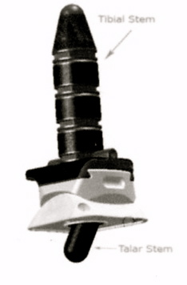
The stems attached to bearing surfaces have not been developed to their fullest extent in other total ankle systems. This is an oversight. Even a stout talar stem is better fixation than the talar fins or screws used by most prostheses. Studies from the University of Nebraska have shown that the longer and thicker the stem, the more load is removed from the bearing component. (Unpublished data from Hani Hanider, Ph.D.) The calcaneal stem used in Reiley’s Topez model provides load sharing of up to 60%, depending on the width and length of the stem. The positive biomechanical consequences of unloading both the shear and compressive loads from the talar dome by a calcaneal stem, means that the fusion of an immobile, unstable, or arthritic sub-talar joint is less of a sacrifice. (2)

- Customized for Patient Needs
The Topez Total Ankle comes in six sizes, left and right. In addition, the modular design of the tibial stem allows for a custom fit. The tibial stem is segmented for complete customization to patient size and bone structure. Typically 4 stem segments are joined to form one long stem, but more or fewer segments can be used to suit individual patients. Another benefit is that the segmented design allows a less invasive surgical procedure in which the tibial stem can be inserted piece-by-piece into a small opening with minimal bone removal. The talar stem is available in two lengths, 10 and 14 mm, to maximize the talus anchoring depth for specific patients. (1)

- Thick Ultra High Molecular Weight Polyethylene Bearing
The POLY used in the Topez ankle is available in two thicknesses for each of the 5 prostheses sizes ( ex. 9 mm and 11 mm thick for the mid-range size #4 prosthesis). It has been shown that greater POLY thickness provides greater longevity for the prosthesis. (1)
The polyethylene thickness of all of today’s total ankle systems, whether European, Japanese, or American, averages between 3 and 7 mm. It has been known for two decades that a tibial plateau of less than 9 mm of polyethylene wears out in three to seven years. (2)

- Anatomical Talar Component
The talar component of the Topez Total Ankle closely matches the shape of the natural human talus. This anatomical shape duplicates the smooth natural movement of the human ankle. (1)
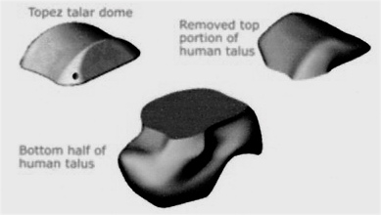
It has been suggested that forth-coming total ankle replacements will include anatomically shaped talar components. (Easeley, et.al) This does not appear to be true of the STAR nor the Tornier Ankle whose mechanics mimic those of the STAR. However Reiley’s Topez Total Ankle has a double saddle design which closely emulates the true contact surfaces of the human ankle. (2)

- Large Talar Surface Area
The bearing surface area of the Topez Total Ankle talar component is 1.5 to 2 times greater than any other ankle implant in the US market. This large base of support helps to stabilize the joint and reduce stresses—one of the major problems with historical designs. (1)

Poor coverage of the inferior weight-bearing surface in either total knee replacements or total ankle replacements leads to component subsidence and, in the ankle, talar fractures can occur in the Agility prosthesis. (Personal communication from Sigvard Hansen to Mark Reiley in 2003). (2)

It is well known that the ankle has one third the surface of the knee, yet carries almost twice the load of the knee. The Reiley Topez Total Ankle has from 2 to 2.5 the articular surface area of the Agility prosthesis. The larger the surface of the talar componenet, the less load per square millimeter and the less the probability of talar subsidence. (2)

- Preservation of the Medial Malleolus and Fibula
The innovative trapezoidal design of the tibial component preserves a major portion of the medial malleolus, and the fibula is left totally intact. (1)

- Precision Installation Using Intra-Medullary Guidance
Consistently accurate installation can be achieved with the patented Topez FootHolder and surgical instruments. The FootHolder secures the ankle, while allowing the surgeon to adjust translation and rotation throughout the procedure. Precise cutting guides define the exact saw cuts. Custom tooling developed for each surgical step ensures precise and consistent surgical installation. (1)
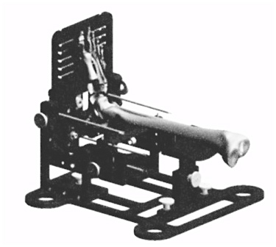
It is uniformly recognized that even three degrees of varus deformity in prosthetic positioning can cause premature loosening. Over a 30 year period, total knee guidance systems improved from “nearly freehand” to extra-medullary guidance, to the current intra-medullary guidance which produces reliable and reproducible cuts in the bones. It is believed that the introduction of intra-medullary guidance, on average, increased the life span of total knee replacements by seven to eight years. No knee surgeon would go back in time to use an extra-medullary system to guide the femoral cuts. (2)

Yet, all total ankle systems, except Reiley’s Topez model, rely on extra-medullary guidance apparatus which is known to give rise to inaccurate bony cuts. At least two papers by foot and ankle surgeons suggest that extra-medullary guidance is insufficient for total ankle surgery. (Saltzman et.al, and Huber, et. al) (2)

8. Summary:
Both the tibial and talar bearing components are well-supported by stems of adjustable lengths. The polyethylene has been thickened to lessen abrasion and wear. Third, talar coverage has been maximized to spread out the ankle loads and help prevent talar component subsidence. Fourth, an intra-medullary guidance system has been developed for this ankle system to help insure reproducible and accurate bony cuts for proper alignment of the prosthesis. And finally, the prosthetic design mimics the geometry of the articulating surfaces of the ankle to more closely replicate the motion of the human ankle. (2)

I. B. Differences between Agility and Topez Total Ankle Replacement Systems (TARs)

The documents Topez provided to FDA in their application for approval used the DePuy Agility model as the SE Predicate for comparison and contrast. Accordingly, many aspects of the Agility TAR are common to the Topez model, including (a) Indications for Use; (b) Classification; (c) Description; (d) Materials; and (e) Accessories. There are, however, several significant improvements:

- Contact Area for the Talus & UHMWPE (Polyethylene)
Increased contact area reduces the material stresses. (3)

Topez DePuy Agility

Size 1 0.569 sq. in. 0.209 sq. in.
Size 2 0.718 0.271
Size 3 0.884 0.296
Size 4 1.068 0.41
Size 5 1.268 0.558
Size 6 1.486 0.767

- Contact Stresses at 5 BW (body weight) Talus & UHMWPE
The Topez reduced the load on the prosthesis dramatically. (3)

Topez DePuy Agility

Size 1 1432 psi 3899 psi
Size 2 1135 3007
Size 3 922 2753
Size 4 763 1988
Size 5 643 1461
Size 6 548 1063

- Tibial Tray Differences
The DePuy tibial tray has integral sidewalls for Medial-Lateral constraint of the talus. The Topez design relies on the natural physiological constraint provided by the fibula, medial malleolus, and concavity of the talar dome/UHMWPE interface. (3)

- Coating
The coating for the DePuy Agility Ankle prosthesis is described in
the FDA approval document as: “Porous coated distal surface and
fin talar components.” The coating for the Topez Ankle prosthesis
is described: “Plasma spray coated distal talar surface, proximal
tibial surface, tibial stem and talar stem.” (3)

I. C. Illustrations of Differences Between Agility

and Topez TAR Models

X-Ray Photos of Agility and Topez Models-*//
The following x-rays of a DuPuy Agility TAR and the Topez TAR demonstrate clearly the design differences, especially with regard to the length of the tibial and calcaneal stems. (4)
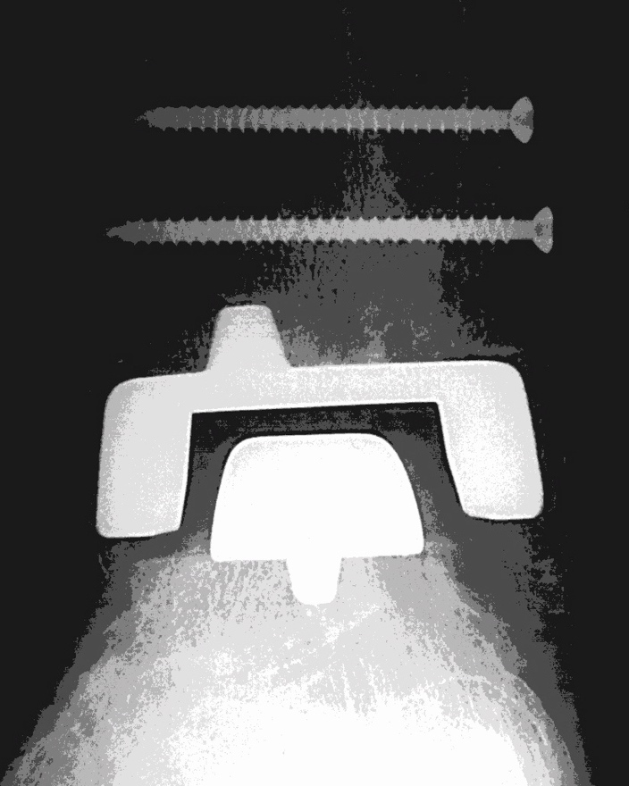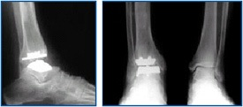
Short-stemmed Agility TAR Model (4)

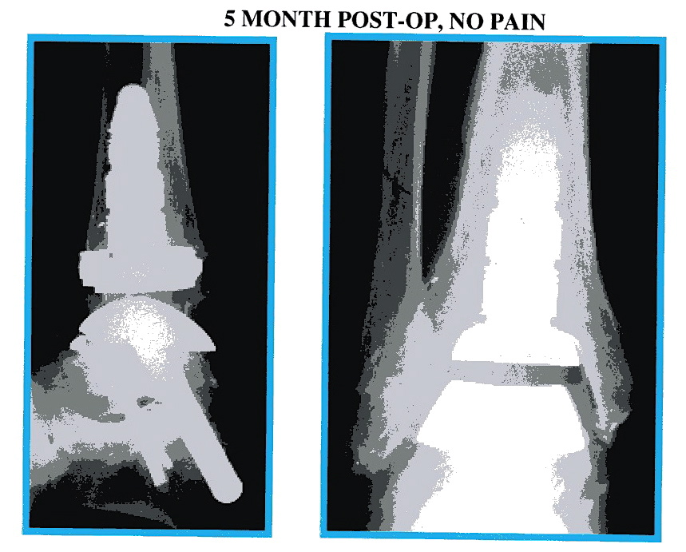
Long-stemmed Topez TAR Model (2)
Note that fibula and malleoli are not excised.

  - Bone Loss Required for Agility TAR
Additional illustrations demonstrate the bone loss from the tibia, fibula, and malleoli that is often required for installation of the Agility model. (5) The Topez TAR does not require cutting the fibula and leaves most of the medial malleolus intact. (2)

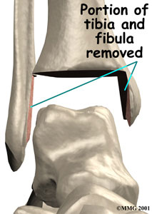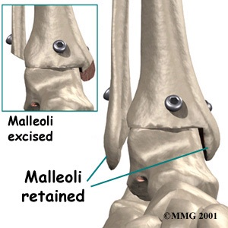
Agility Topez

  - Bone Grafts Required for Agility Installation
In addition to requiring excision of bone as illustrated above, the Agility model requires bone grafting. (5) The Topez TAR does not
require bone grafts. (2)

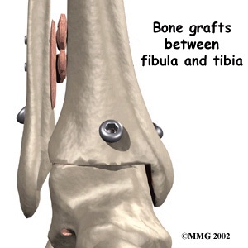
Agility

I. D. Additional Documentation of Topez Total Ankle Replacement

1. Presentation by Mark Reiley, MD, to the American Orthopaedic Foot & Ankle Society at its Annual Summer Meeting in La Jolla, CA on July 14-16, 2006. Note that entire session is devoted to Total Ankle Arthroplasty. (6)


American Orthopaedic Foot & Ankle Society
Annual Summer Meeting
Hilton Torrey Pines Resort
La Jolla, California
July 14 – 16, 2006
Friday, July 14, 2006

7:45 – 8:20am Paper Session III: Total Ankle Arthroplasty
Moderator: Michael Pinzur, MD
Co-Moderator: Andrew Fred Robinson, MD

7:45-7:51am A First Look Outcome Study for a New FDA Approved Total Ankle
Presenting and Corresponding Author: Mark A. Reiley, MD

7:51-7:57am Analysis of Gait Pre and Post Total Ankle Arthroplasty, Post Ankle and Comparison with a Control Population Presenting and Corresponding Author: Philippe Piriou, MD Additional Authors: Thierry Judet, MD; Mark Mullins, MD

7:57-8:03am Total Ankle Replacement in Ankle Osteoarthritis: An Analysis of Muscle Rehabilitation Presenting and Corresponding Author: Victor Valderrabano, MD
Additional Authors: Benno Nigg; Vinzenz von Tscharner; Cyril Frank; Beat Hintermann, MD

8:03-8:09am Early Results for the Agility Stemmed Talar Revisional Component for Total Arthroplasty Presenting and Corresponding Author: Gregory Alvine, MD
Additional Authors: Jerome K. Steck, DPM; Frank Alvine, MD

2. American Orthopaedic Foot & Ankle Society Position Statement re Total Ankle Arthroplasty June 6, 2003

“Ankle arthritis has many treatment options, both operative and non-operative. Operative treatment is available for patients with persistent symptoms. Surgical options include joint debridement, distraction arthroplasty, osteotomy, ankle arthrodesis and total ankle arthroplasty. Total ankle arthroplasty is a viable option for the treatment of ankle arthritis. As with all total joint replacements, you should consult with an orthopaedic surgeon.” (7)

3. Federal Drug Administration Approval

The Topez Total Ankle Replacement was approved by FDA on November 15, 2005 with the 510 (k) number: K05 1023. (3)

  - Contact between Mark Reiley, MD, and the Blue Cross Medical team results in update of Blue Cross policy to include Topez model.

Following the Blue Cross denial of benefits for my TAR surgery, Dr. Reiley had telephone contact with at least three Blue Cross physicians.
  - Ronald E. Giles, MD, FACS, Medical Director
  - Dr. Manley
  - Dr. Prows
Reiley also sent packets of information regarding the Topez TAR to Blue Cross where it was reviewed by the Regence Medical Policy Workgroup during the week of July 7-14, 2006. According to Dr. Giles, the Workgroup requested that the Blue Cross policy be updated to include information about the Topez TAR.
In his letter to Dr. Reiley, the Blue Cross Medical Director, Dr. Giles, commented, “The Topez prosthesis certainly appears more promising than prior protheses, but due to the lack of published studies, the Topez prosthesis will also continue to be considered investigational at this time. He went on to say, “Although the Topez is considered investigational and does not currently meet our research urgent policy criteria, the member can request consideration based on her clinical status, and an exception could be made by the appeal panel.” (8)

E. Insurance Companies Providing Benefits for

Total Ankle Replacement Surgeries

1. Blue Cross affiliates that have covered TAR surgeries:

  - Premera Blue Cross of Alaska
  - Blue Cross of California
  - Anthem Blue Cross of Indiana
  - Blue Cross First Priority of Pennsylvania

2. Other Insurance Companies that have covered TAR surgeries

  - Cigna

  - HealthNet of Connecticut

  - United Health Care

3. Insurance companies covering Topez TAR surgeries in 2006
  - Alta Bates HMO
  - Blue Cross of California
  - Healthnet Seniority Plus
  - Medicare

Note: This listing is not complete, but documents the reports from members of the Ankle Replacement Discussion Group Archives & personal communication with TAR recipients; (9) also personal communication with Topez TAR surgery coordinator in Dr. Reiley’s office.

II. Rationale for Patient’s Need for
Topez Total Ankle Replacement

II. A. Orthopedic History

1. Ankles Identified as Problem in Childhood
In February 2006 I finally learned the reason for a lifetime of foot and ankle problems. A CT scan revealed the culprit—a congenital defect called "tarsal coalition" where the heel is fused to the ankle. (10) At age 5, I was taken to an orthopedic specialist where I got my first pair of high-top “special” shoes and orthotic inserts. Fortunately modern specialists know that conservative treatment like that doesn't work and are able to save children from years of unnecessary pain and humiliation.
- Congenital Bilateral Tarsal Coalition Diagnosed in 2006
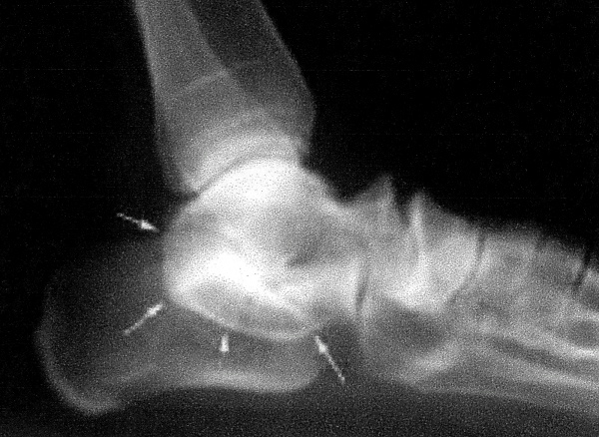
X-ray shows tarsal coalition similar to that of patient
This condition affects about 1% of the population, and orthopedists can identify and correct it in childhood. Now when tarsal coalition is diagnosed in children with flat feet, weak ankles, and pronation, the bones are surgically separated before the structure of their ankles and legs is permanently affected.
Notwithstanding many more consultations with specialists and dozens of special shoes and custom-made orthotics, I’ve had weak ankles, dozens of sprains, a few broken foot bones, and increasing foot and ankle pain all my life. I was never able to participate in athletics, hiking, or even regular walking—swimming was my only successful athletic endeavor.

- Congenital Bilateral Crossover Deformity of the Fifth Toes.
I was also born with funny toes that didn’t straighten out even after years of splints, cotton balls, wide-toed shoes, or youthful hope. Although often called hammer toes, this condition is now distinguished from hammer or bent toes and is labeled “Congenital Crossover Deformity of the Fifth Toes.” According to Nicklas, this deformity presents as adduction of the little toe with some external rotation of the digit. The metatarsophalangeal joint is dorsiflexed, and the nail plate is often smaller than expected. (11)

In my mid-twenties I prepared to move from my home in the Southwest to the colder climate of the Midwest. I also had to face the fact that sandals-only was no longer an option for year-round footwear. My crossed-over toes had required open-toe shoes that would soon be a serious liability in snow and slush. So I arranged to have my toes surgically restructured just weeks before the big move and the start of my first high school teaching job.
The crossover toes were corrected with V-Y arthroplasty and the fourth and fifth toes were webbed or syndactylized; most of the bone was removed from the 5th toes. (11)

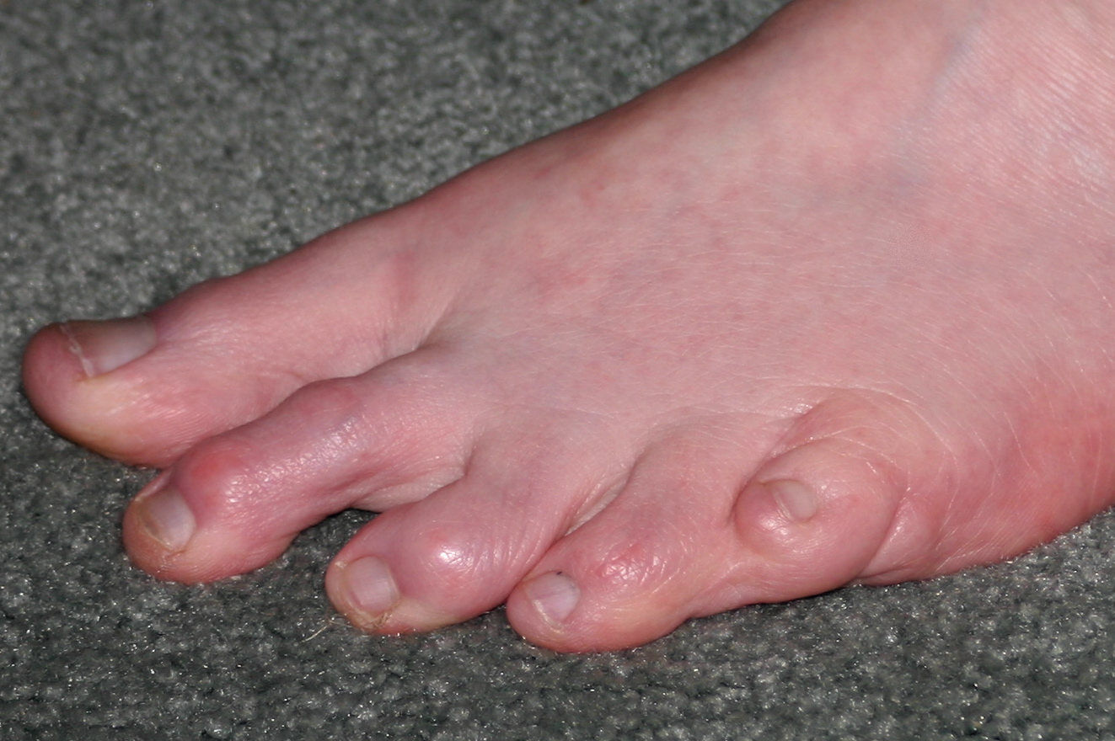
Unfortunately the surgeon neglected to tell me that he had never done this surgery on both feet simultaneously and didn’t realize how long and difficult the recovery would be. I hobbled around in open-toed tennis shoes for the first few months of that school year. Those surgeries are long healed; those little toes are still unusual, but no longer a problem. Corrected little toe 35+ years later

4. Feet & Ankle Problems Affect Career Choices

By the end of my first year in college I was enthusiastically headed for a life of adventure and exploration as an anthropologist. However, it soon became apparent that I was not able to walk and hike to the remote field sites this work requires. I had to reconsider my options and settled on a relatively sedentary career as an indoor educator. I worked as a teacher, principal, and college professor for the 40 years of my professional life. Standing was always difficult and many lectures and discussions were delivered from a seated position. Weakness and pain in my feet and ankles also limited the extra-curricular activities I could sponsor or support. Debate teams were in; sports teams, drama, and dance activities were out.
Although I was not able to be physically active, I had a very productive and satisfying career and made substantial contributions to the field. I completed my Ph.D. before I was 30 and specialized in Curriculum, Instruction, and Staff development. In that leadership role, I presented papers and led workshops at hundreds Collage of awards & publications
of national and international education conferences. In 1987 I was honored by the California State Board of Education with its First Place Golden Bell Award for Innovative Curriculum.
After moving to Newport in 1990, I trained Lincoln County teachers to use Oregon’s new standards based assessments. Later I spent my last few years as principal of two elementary schools (due to budget cuts). At the same time, I coordinated and taught for the PSU Master’s in Education that improved the quality of instruction for thousands of students when over 60 Lincoln County teachers completed the program. I helped establish and have continued to serve as co-chair of the District’s Crisis Response Team, providing training and leadership when there is a death or tragedy in the school community.
5. Foot & Ankle Problems Affect Retirement Plans
When I retired in 2001, I began making travel plans. I wanted to visit some of those places I had read and taught about but had never seen. The first year we visited friends, family, and historical sites in the Northwest—and were finally able to spend more time with my grandson (and his family) in Monterey. It soon became very apparent that my outdoor activities had to be limited to short walks and the availability of benches or seating. Leisurely walks on the beach or through quaint villages had become spectator sports for me.
On our first long trip in 2003, the joy of Australian sightseeing was dampened by terrible ankle pain if I tried to walk even a few blocks. When I returned home, X-rays showed severe degenerative joint disease (DJD), no cartilage, and many bone spurs. My local doctor shook his head and said there was no way I should be able to walk at all. He prescribed a prescription anti-inflammatory and Vicodin for the pain, and referred me to Orthopedics at OHSU.

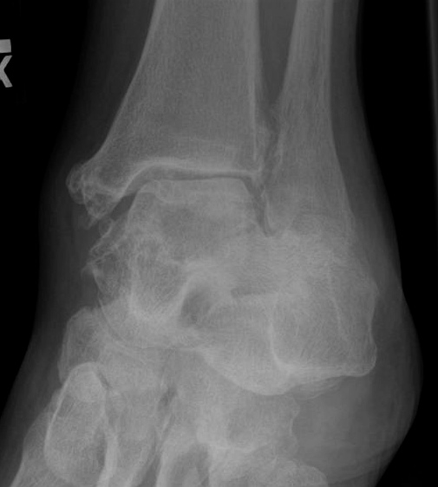
6. Referral to OHSU in 2004
In early 2004 Michael Kennedy, MD, a foot and ankle specialist at OHSU, reviewed the X-rays and recommended ankle replacement as the best of the very limited options available to me. In his opinion, the STAR ankle replacement model was a real improvement over the currently available Agility model, and he said it should be approved by FDA "any time now". He encouraged me to hold off until the STAR was approved if at all possible. 2004 OHSU left ankle X-ray

In the meantime, Kennedy ordered customized high top leather ankle braces (Arizona AFO) that would mimic fusion, and I have worn these braces daily for over two years. For the first year the braces provided good support and made a noticeable difference in the pain level. Since then, the braces don’t affect the increasing pain levels, but do provide more stability for my limited walking.

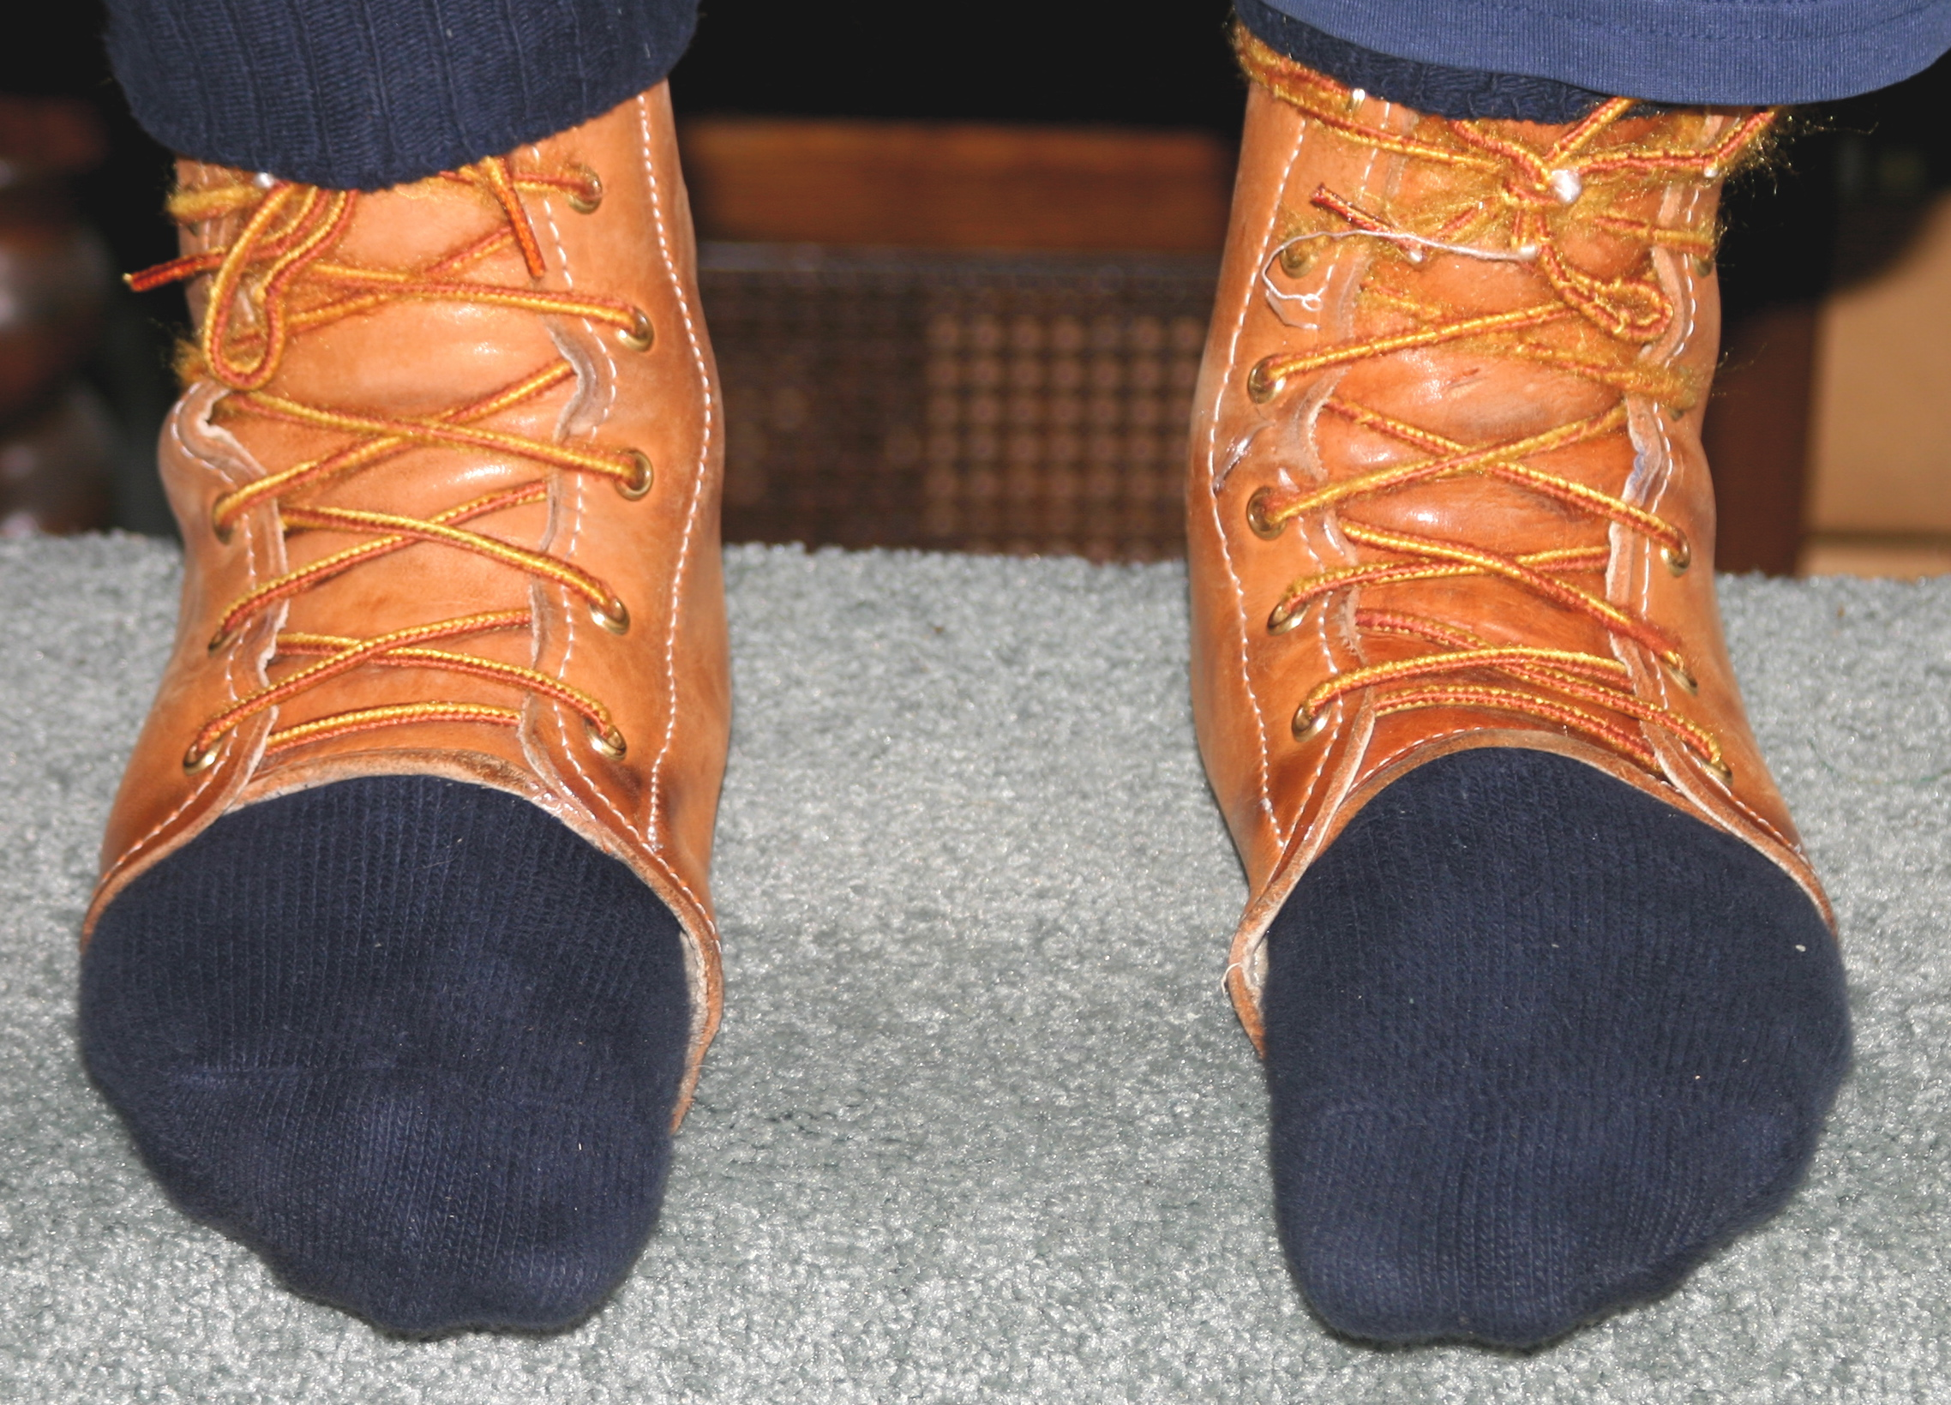 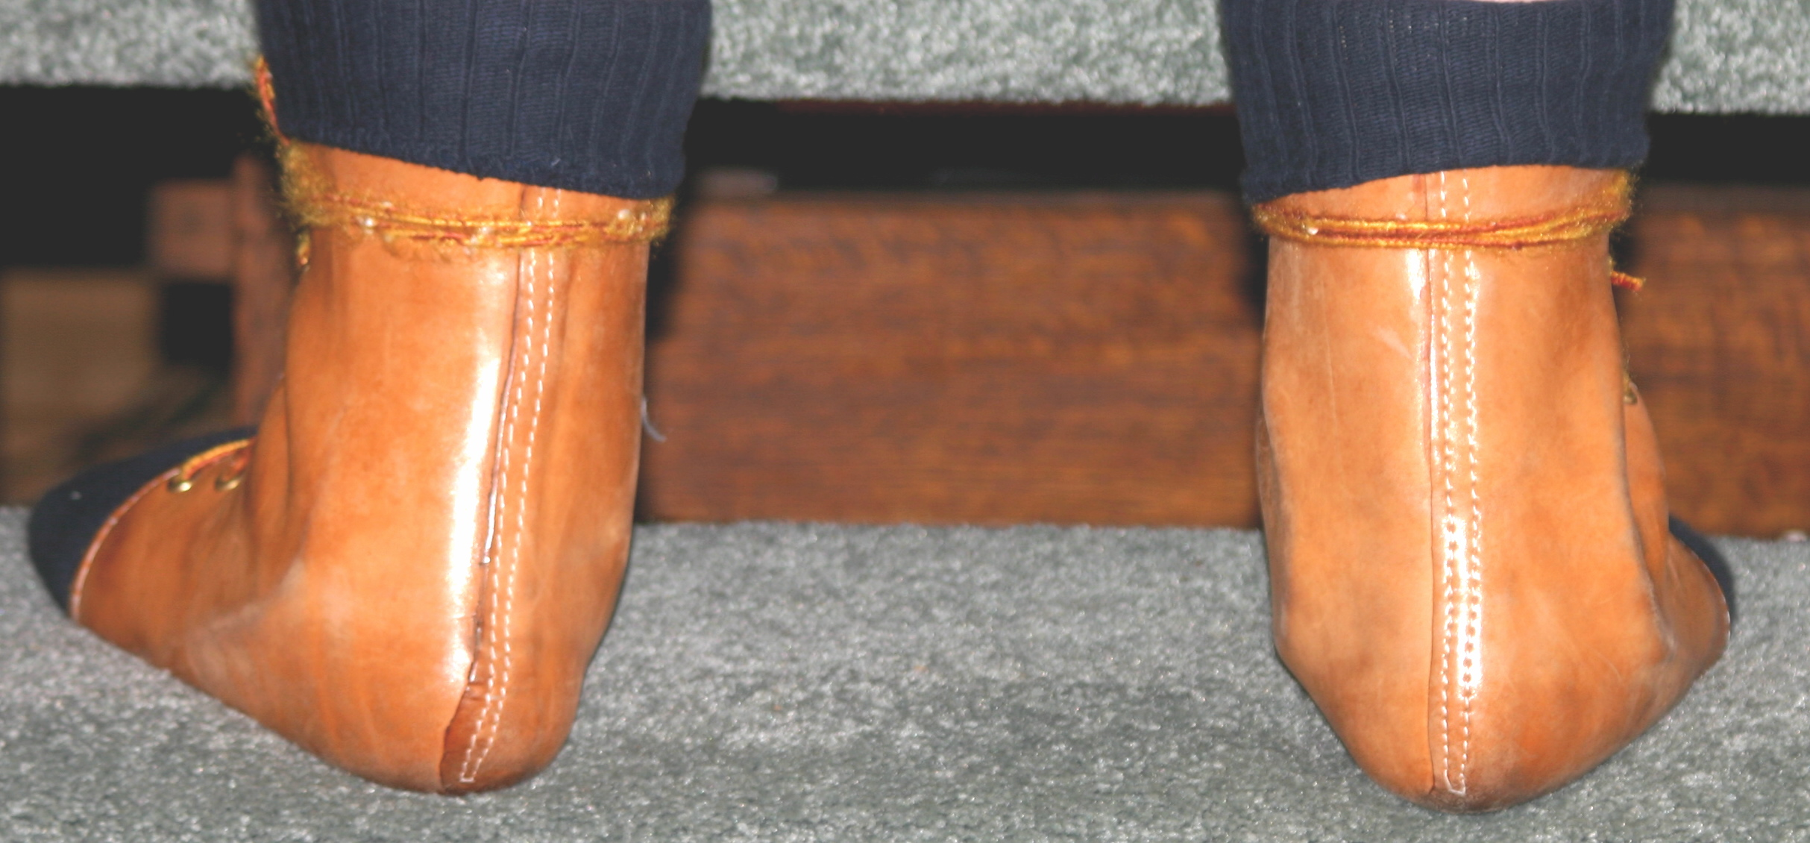 Arizona Ankle/Foot Orthotics somewhat improve pronation & provide support

In the spring of 2005 Dr. Kennedy gave me an intensely painful series of viscous Supartz injections (like Synvisc) that did relieve some of the pain for about 6 weeks—but then the grinding bone/bone pain was back. I decided that Supartz did not provide enough relief to justify either the pain or the expense of another round of injections.
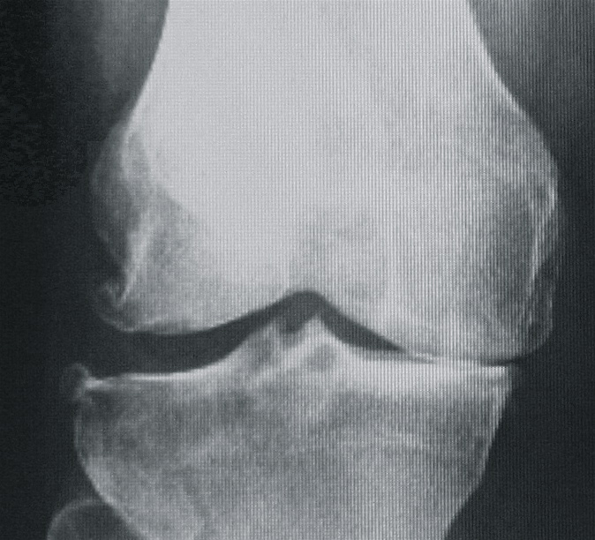
In the fall of 2005 Dr. Kennedy reviewed current X-rays of my ankles and my newly painful right knee. It was his opinion that the degeneration of the knee joint was related to the misalignment and degeneration of the ankle joints. He determined from the X-rays and physical examination that I needed a knee replacement, which he said must be completed and healed before any form of ankle surgery. (12) Right knee pre-op

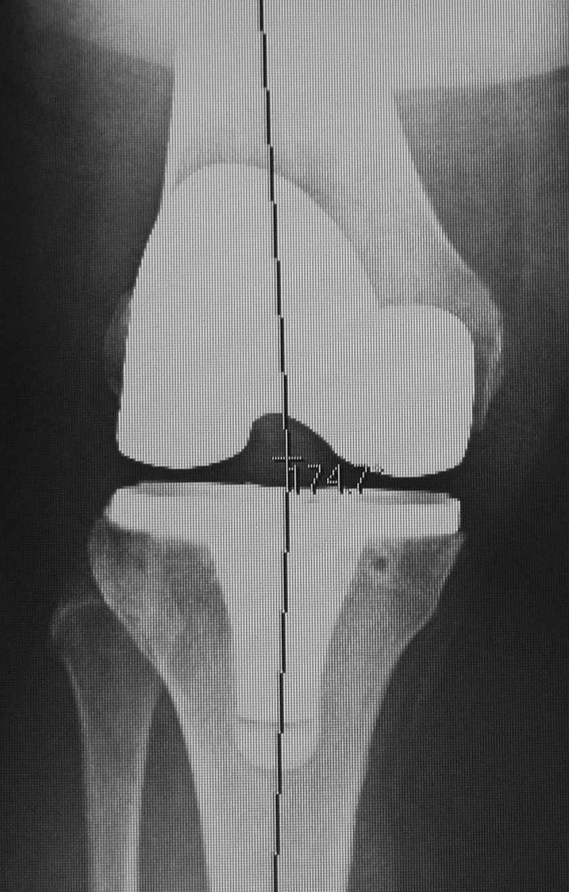
7. Total Right Knee Arthroplasty in 2005
I had a total right knee arthroplasty (TKA) in December, 2005 with Dr. John Coen in Corvallis. This surgery was most successful; I healed quickly, was able to drive in just two weeks, and regained full range of motion (to 137 degrees) within 10 weeks. At this time I have no pain or limitation in that knee nine months after the surgery. This positive response to recent joint replacement surgery was very encouraging to the three ankle specialists I’ve seen in 2006. (13) Knee post-op 12/05

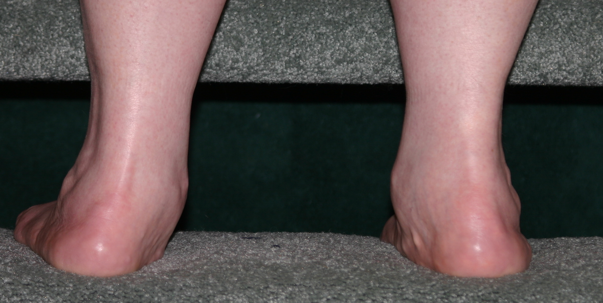
8. Portland Area Foot & Ankle Specialists in 2006
In January 2006 I met with Douglas Beaman, MD, the ankle surgeon recommended by OHSU’s Dr. Kennedy.

Severe pronation & misalignment

After reviewing new X-rays, Dr. Beaman suspected a tarsal coalition that was confirmed with a CT scan at the February appointment. At that time he said I was a candidate for a TAR, and that it would be complicated by the misalignment of my ankle and leg. Because Dr. Beaman doesn't do the TAR surgery, he referred me to James Davitt, MD, a Portland area surgeon who does ankle replacements —but only the Agility model. (14)

9. Referral to Univ. of Washington Ankle Clinic in March, 2006
In late March I met with Dr. Davitt who declared that my ankles were the worst he’d ever seen—and beyond his skill and experience. He also said that I was the oldest patient he’d seen with an uncorrected tarsal coalition—that most patients have surgery long before retirement age.
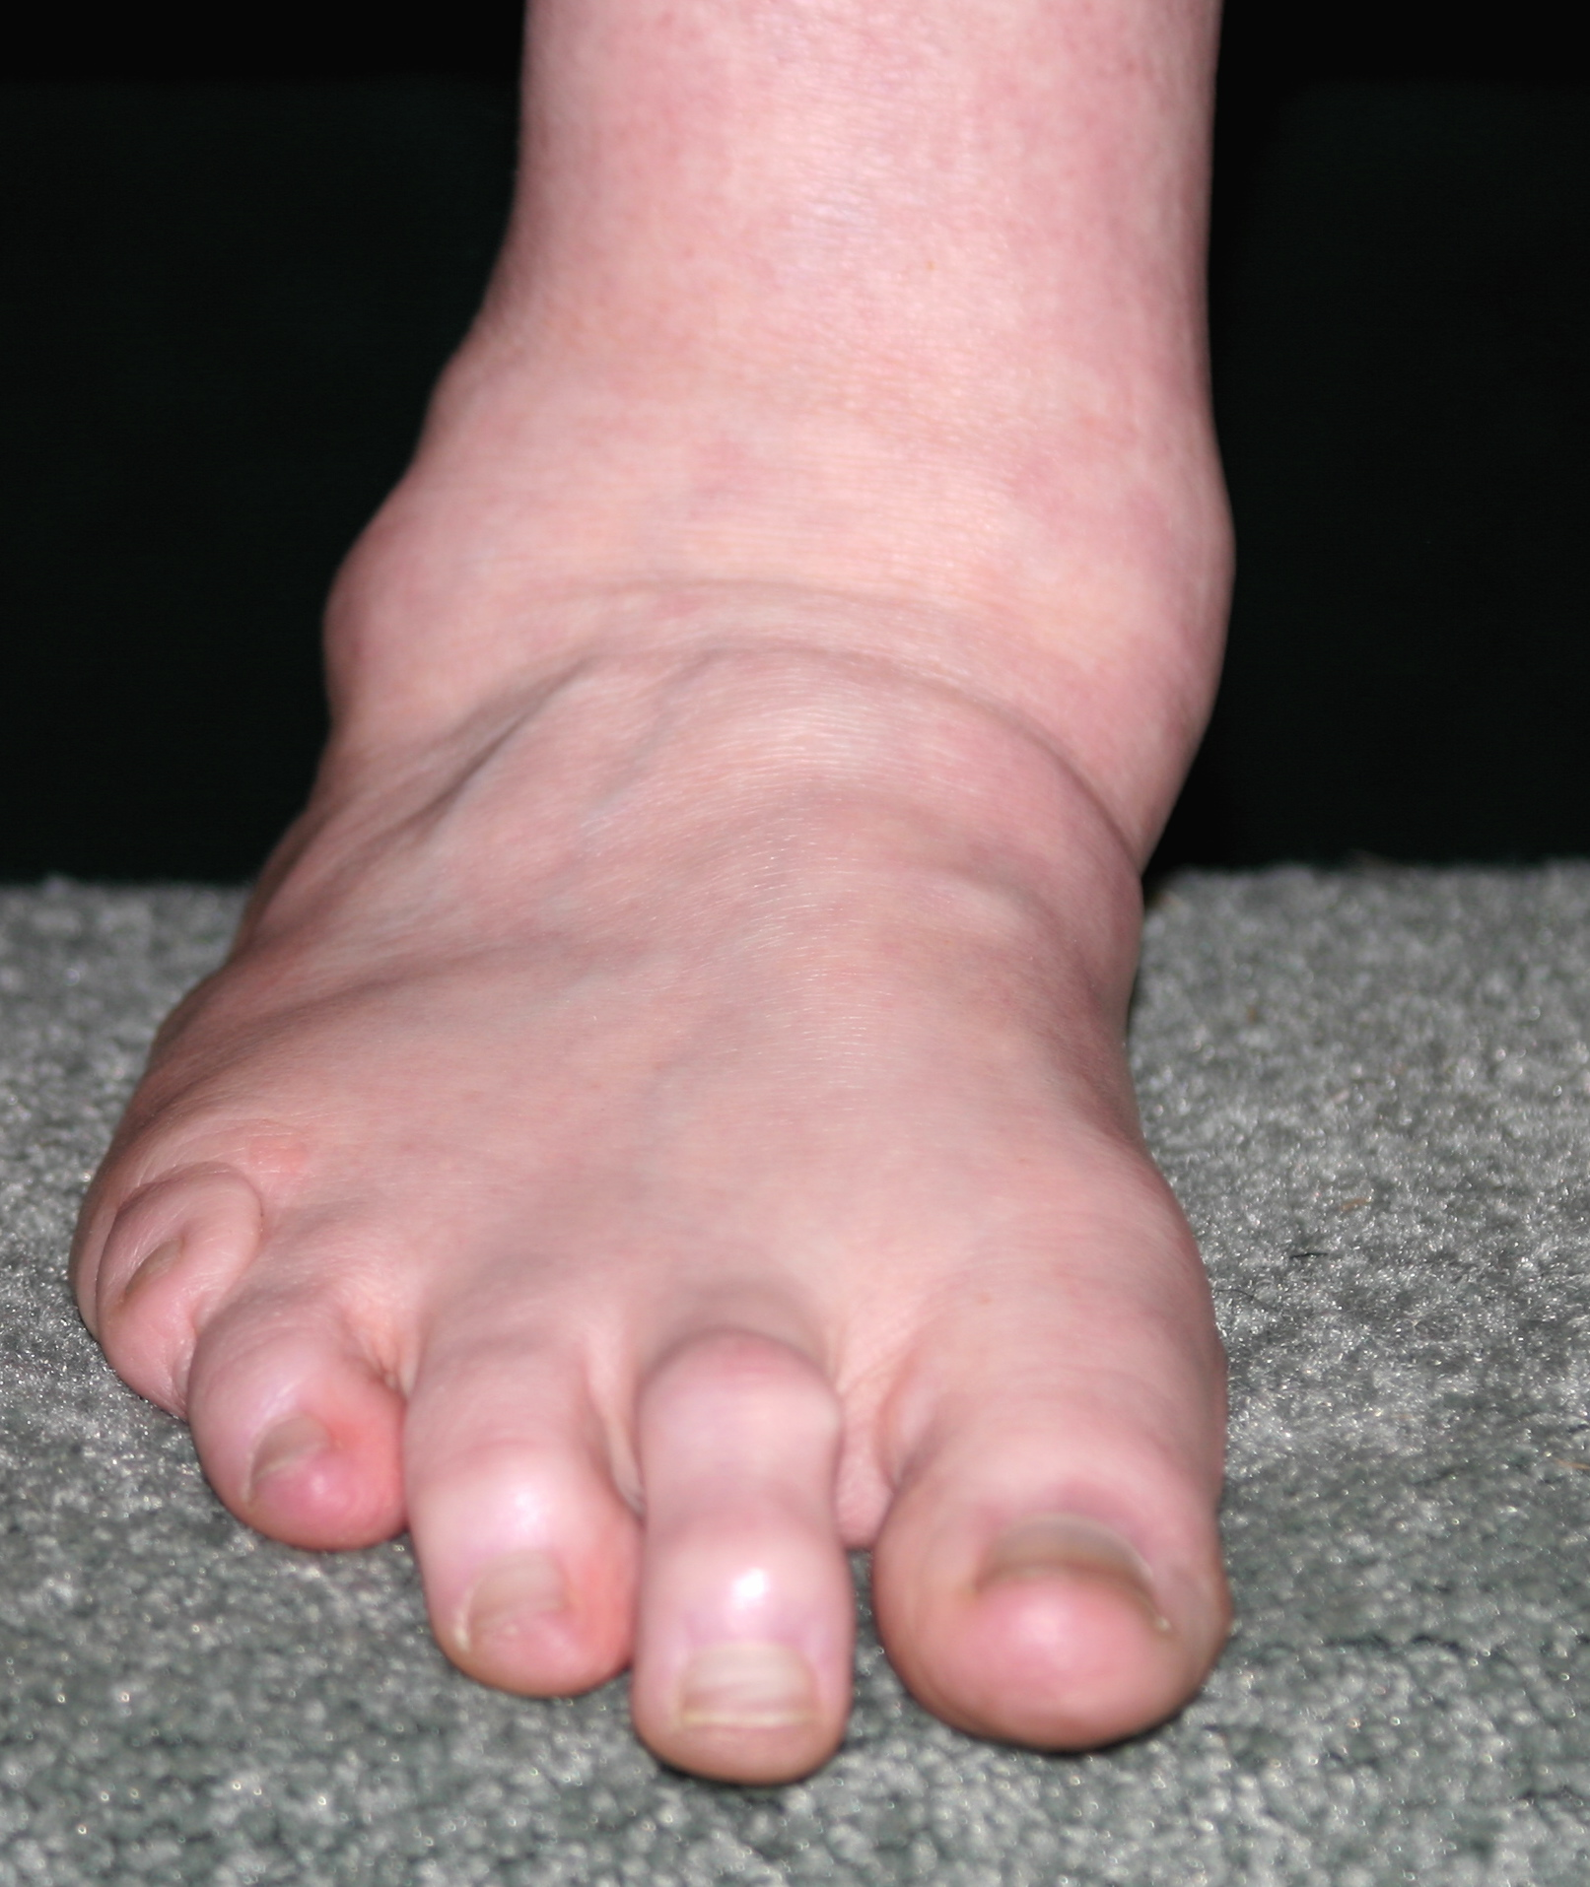 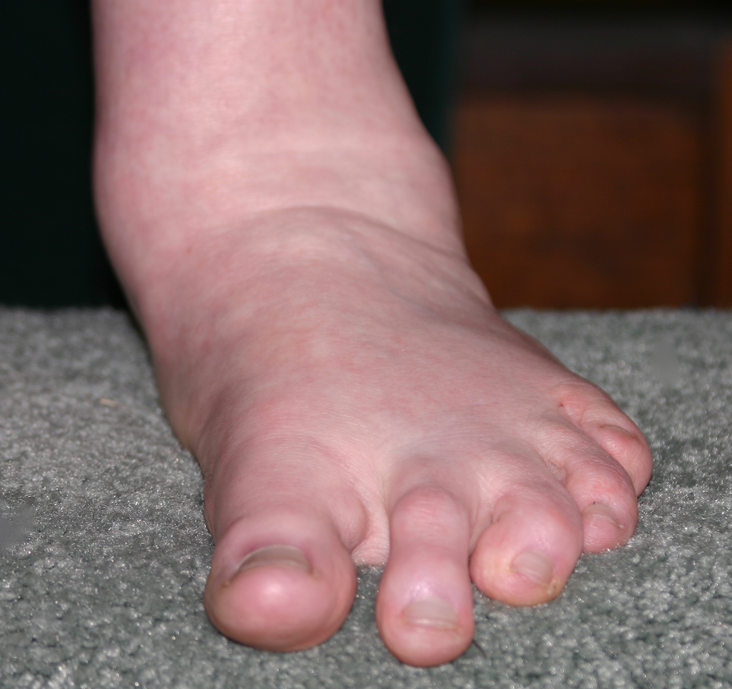 Severe pronation & collapsed ankles due to tarsal coalition
Davitt referred me to Dr. Sigvard Hansen, his teacher/mentor at University of Washgton Medical School in Seattle. Dr. Davitt said it was possible that a team of surgeons could do the reconstruction/alignment and ankle joint replacement (Agility model) in a single surgery. Otherwise, the surgeries would need to be done in two stages with a six to eight month healing period between each pair of surgeries. He arranged a mid-June appointment for me at Harborview Clinic in Seatlle. (15)

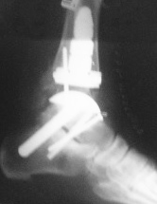
10. Learned of Topez Total Ankle Replacement in April 2006
In April I learned of the Topez TAR procedure from a retired friend in Berkeley who received that TAR in early February and urged me to investigate this new model. Two months after the surgery he was already able to walk comfortably with full weight-bearing. I was interested!
In early May I had an appointment with Dr. Mark Reiley and learned more about the Topez TAR which he Friend’s new Topez ankle
designed. After reviewing my CT scans and a very thorough physical exam, Reiley said the TOPEZ model would be appropriate for me. He explained how the mechanics and engineering of this model would address the misalignment issues as well as providing a replacement for the ankle joint with enough stability to withstand far more stress than the Agility or the STAR models. He also explained how the modular stems extending into the tibia and the talus/calcaneous could be used to correct my misalignment in the same surgery as the ankle joint replacement. (16)
Note: Now at six months post surgery my friend is pain free and has resumed all of his normal activities, including many he had been unable to perform due to ankle pain. (Personal communication with J. Chin)

11. Scheduled and Cancelled Topez TAR Surgery for July 2006
I cancelled the June appointment in Seattle with Dr. Hansen’s team, and scheduled surgery with Dr. Reiley for July 3, 2006. The next few weeks were a flurry of activity as I made the necessary plans and reservations to stay in California for a month, and to be off my feet for 6-8 weeks. Then in mid-June Dr. Reiley and I were notified that it is the policy of Regence Blue Cross/Blue Shield of Oregon to deny benefits for all TAR procedures. This was a totally unexpected development since many other insurance companies, including Blue Cross affiliates in California, have covered many TAR surgeries. In fact, this was the first of Dr. Reiley’s TAR procedures to be denied coverage. (17 & 8)

II. B. Patient’s Current Clinical Status
- Level of Pain
Severe pain (8-9 of 10) is a near-constant reality in my increasingly limited daily activities. I take prescription anti-inflammatories and Vicodin just to manage getting around the house and I take Neurontin when the nerve pain in the lateral malleolus is worse at night. While these medications help, the pain level is rarely below 5-6, and has a strong negative effect on my mental and emotional well-being, in addition to limiting physical movement.

2. Level of Disability--Limitations on Daily Activities
The first few steps each morning are “breathtaking” and I use a walker or hold onto furniture to get down the hallway to the handicapped accessible bathroom. Within half an hour I can usually hobble around the house without a walker, though I keep a cane handy. After the AM meds take effect, I am usually able to shower and dress without assistance.
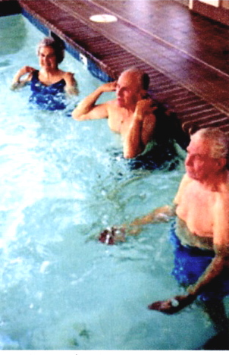
Three or four days each week I drive to the pool for an hour of deep-water aerobic exercise, the only time I can move without severe pain. I wear Velcro braces and jog or bicycle in deep water to avoid any weight bearing or ankle bending. Even so, at least once a week I experience sprained ankle type pain when I move to the shallow end of the pool and resume partial weight bearing. It takes up to half an hour for my ankles to settle into positions that allow me to exit the pool. Water aerobics class
On a good pain day, I can stop for a few groceries on my way home; otherwise I go directly home to take more Vicodin and elevate my ankles. And that’s where I spend much of the rest of the day—in a recliner with feet and ankles elevated while either reading or working on my laptop computer.
When I move to the kitchen to prepare dinner, I use a stool and sit for short periods with my legs down. Food preparation has to be done in small blocks of time interspersed with “feet up” rest periods.

3. Summary
At this time I am unable to walk even a block without excruciating pain. I have a handicapped parking permit; I use motorized carts in grocery stores, or use the grocery cart like a walker. I use a cane or walker to get from the house to the car and use a wheelchair in public facilities like airports, hotels, museums, galleries, etc.

This constant and intense pain limits my life severely and prevents me from enjoying normal social contact with friends and family. I rarely attend any evening gatherings because that’s when the pain level is worst and my tolerance is lowest. Those closest to me recognize the signs of worsening pain and help me get home quickly—and understand my lack of enthusiasm or participation.
My primary care physician reviewed my health systems with me this week. She remarked on how strong and healthy I am, except for the ankle pain. I expect to live another 30 years and want to be active and vital in these retirement years, not an invalid.
Pain is holding me prisoner in my recliner—a safe, but very limiting existence! I want my life back. I want to be able to move more freely, to participate actively in my life, and to visit family and friends easily. I want to take my dog for a walk on the Newport Bayfront, and I especially want to walk on the beach, or even the sidewalk, with my grandson, Devon.

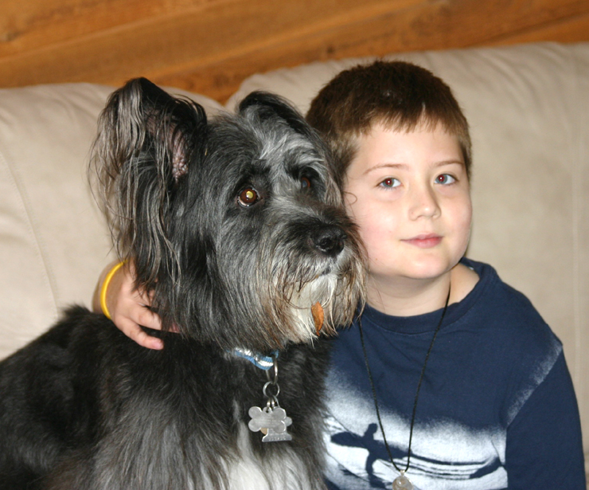 Wilma the Wonder Dog & Grandson Devon

III. A. References & Bibliography

- Topez Orthopedics Total Ankle System Rationale http://www.topezorthopedics.com/healthcare.php?fontsize=

- Design Basis & Surgical Cases for the Reiley Talar/Calcaneal Stem Total Ankle Systems—Topez, Inc.: 12 Cases Using the Reiley Calcaneal Stem by Mark Reiley (Self-published, 2006, Berkeley, CA)

- Topez Total Ankle Replacement Approval by FDA, November 15, 2005
www.fda.gov/cdrh/pdf5/K051023.pdf=

- DePuy Agility X-Ray Photo
http://www.depuyorthopaedics.com/bgdisplay.jhtml?itemname=photolargeextrimitie2

- DePuy Agility Ankle Joint Replacement
http://www.jointreplacement.com/xq/ASP.default/pg.content/content_id.75/mn.local/joint_id.7/joint_nm.Ankle/local_id.38/qx/default.htm

- American Orthopaedic Foot & Ankle Society Summer 2006 Meeting Program http://www.aofas.org/i4a/pages/index.cfm?pageid=4245

- American Orthopaedic Foot & Ankle Society Position Statement re Total Ankle Replacement http://www.aofas.org/i4a/pages/index.cfm?pageid=3676

- Letter from Blue Cross Medical Director, Ronald Giles, MD, to Mark Reiley, MD dated 7/14/06 (attached)

- Ankle Replacement Discussion Group Online
http://health.groups.yahoo.com/group/Ankle_Joint_Replacement/messages

- Tarsal Coalition X-Ray Illustrating the Areas of Fusion http://www.emedicine.com/radio/images/5664P1030836CoalSubtalLatCsignArrow.jpg

- Illustration of Crossover Fifth Toe Deformity Corrected with V-Y
Arthroplasty from “Surgical Management of Digital Deformities” by Bonnie J. Nicklas in Textbook of Hallux Valgus and Forefoot Surgery, ed. Vincent J. Hetherington, Ohio College of Podiatric Medicine, 2000.

- 2004-2005 Case Notes re Jeanne St.John from Michael Kennedy, MD, OHSU Orthopedics, Portland, OR (attached)

- 2005-2006 Case Notes re Jeanne St.John from John Coen, MD, Corvallis
OR (attached)

- 2006 Case Notes re Jeanne St.John from Douglas Beaman, MD, Portland
Orthopedic Specialists, Portland, OR (attached)

- 2006 Case Notes re Jeanne St.John from James Davitt, MD, Orthopedics &
Fracture Clinic, Beaverton, OR (attached)

- 2006 Case Notes re Jeanne St.John from Mark Reiley, MD, Berkeley
Orthopaedics, Berkeley, CA (attached)

- Letter from Blue Cross Grievance Coordinator, Sheri Yuckert, to Jeanne
St.John, dated 6/29/06 (attached)

III.B. Case Notes from Patient’s Orthopedists

1. John Coen, MD, Corvallis, OR Dec. 2005-June 2006

2. Mark Reiley, MD, Berkeley, CA May 2006
3. James Davitt, MD, Beaverton, OR March 2006

4. Douglas Beaman, MD, Portland, OR Jan.-Feb. 2006

5. Michael Kennedy, MD, OHSU 2004-2005

III.C. Letters from Blue Cross Denying Total Ankle Replacement

1. Sheri Yuckert, Grievance Coordinator 6/29/06
2. Ronald Giles, MD, Medical Director 7/14/06

