DR. MARTIN P. FRICKE
Brief Bio and Current Activities
May, 2017

Dr. Martin P. Fricke has a PhD in nuclear physics and is a Senior Fellow of the American Physical Society (APS, 50,000 members), where he was once elected to its 15-member Executive Panel on Public Affairs. He did research in nuclear physics at the University of Minnesota, the University of Michigan, and at the Oak Ridge National Laboratory under a national fellowship. He later became a corporate officer (CEO, COO, Sr. VP, VP) of seven multidisciplinary R&D companies in San Diego and elsewhere. He has over 100 publications*, most of which are classified, and has delivered invited talks at international symposia.

Much of Dr. Fricke's career has been devoted to supporting the U.S. Intelligence Community, requiring multiple-Agency Top Secret and special compartmented data, SCI (SITKɣ/SAP/Byeman), clearances. He personally interacted with the Director of Central Intelligence (now termed Director of National Intelligence), who is in charge of all U.S. intelligence activities, CIA, DIA, NSA, military, etc. He led programs for CIA involving the collection of information on Soviet weapons research. He also led nationally important programs for the Dept. of Defense, which remain classified. These included interacting directly with the Secretary of Defense and involved nuclear weapons and exotic directed energy weapons.

The Citation on his APS Fellowship Certificate reads: "For research on the uses of particle beams as weapons, assessment of Soviet weapons technology, and applications of physics to weapons development."

*Most of Dr. Fricke's unclassified papers were published before 1985.

Examples of early classified presentations with unclassified titles are:

M. P. Fricke and G. Gamota, "Foreign Applied Sciences Assessment Center," presented to Dr. George A. Keyworth, Science Advisor to the President, 21 February 1984. M. P. Fricke, "Foreign Applied Sciences Assessment Center," presented to the Hon. William J. Casey, DCI, 19 January 1983. M. P. Fricke and T. Armstrong, "Material Interaction Phenomenology," USAF Joint Conference on Particle Beam Technology, Air force Weapons Laboratory, Kirtland AFB, 7-9 July 1976. M. P. Fricke, "Preliminary Civilian Casualty Criteria for Low-Yield Nuclear Weapons, Short-Term Effects," Military Operations Research Society 38th Symposium, 3-5 December 1974.

Examples of unclassified publications on nuclear physics in top peer-reviewed journals and presentations at international symposia are primarily in two areas of nuclear physics.

Direct Reactions:

V. E. Lewis et al. (King's Coll., Univ. of London), N. K. Ganguly (Rutherford High Energy Lab.) and M. P. Fricke (Univ. Mich.), "Analysis of the Inelastic Scattering of 50 MeV Protons," Nuclear Phys. A a117, 673 (1968). M. P. Fricke et al., "Inelastic Scattering of 40-MeV Polarized Protons," Phys. Rev. 163, 1153 (1967). M. P. Fricke et al., "Polarization and Differential Cross Section for Elastic Scattering of 40-MeV Protons II, Phys. Rev. 156, 1207 (1967). M. P. Fricke et al., "Asymmetry in the Inelastic Scattering of 40-MeV Polarized Protons," International Nuclear Physics Conference, Gatlinburg, Tennessee, Sept. 12-17, 1966, Academic Press, New York, 1967. M. P. Fricke et al., "Asymmetry in the Inelastic Scattering of 40-MeV Polarized Protons," Phys. Rev. Letters 16, 746 (1966). A. Scott and M. P. Fricke, "Inelastic Scattering of 40 MeV Protons by ²⁰⁸Pb," Phys. Letters 20, 654 (1966). M. P. Fricke and G. R. Satchler, "Analysis of the Scattering of 40-MeV Protons," Phys. Rev. 139, B567 (1965).

Compound-Nucleus Reactions:

M. P. Fricke and J. M. Neill, "The (n, gn') Reaction in Calculations of Fast Reactor Neutron Spectra," Nucl. Sci. Engr. 50, 392 (1973). M. P. Fricke et al. "Radiative Capture Cross-Sections for 1-1000 keV Neutrons," Proc. Third Conf. on Neutron Cross Sections and Technology, Knoxville, Tennessee, March 15-17, 1971, CONF 710301, I, 252, USAEC (1971). M. P. Fricke et al., "Measurements of Cross-Sections for the Radiative Capture of 1-keV to 1-MeV Neutrons by Mo, Rh, Gd, Ta, W, Re, Au and ²³⁸U," Second International Conference on Nuclear Data for Reactors, Helsinki, Finland, June 15-19, 1970, Vol. II, p. 265, IAEA, Vienna (1970); "Calculations of Cross-Sections for the Radiative Capture of Fast Neutrons," loc. cit. p. 281. M. P. Fricke and W. M. Lopez, "Total Radiation Width for Fast Neutron Radiative Capture," Phys. Letters 29B, 393 (1969).

Pre-Ph.D. Publications:

Dr. Fricke had several major publications in top peer-reviewed journals before receiving his Ph.D. Four of these in the two most prestigious journals in physics are:
1. M. P. Fricke and G. R. Satchler, "Analysis of the Scattering of 40-MeV Protons," Phys. Rev. 139, B567 (1965)
2. M. P. Fricke et al., "Asymmetry in the Inelastic Scattering of 40-MeV Polarized Protons," Phys. Rev. Letters 16, 746 (1966)
3. M. P. Fricke et al., "Polarization and Differential Cross Section for Elastic Scattering of 40-MeV Protons II, Phys. Rev. 156, 1207 (1967)
4. M. P. Fricke et al., "Inelastic Scattering of 40-MeV Polarized Protons," Phys. Rev. 163, 1153 (1967)

Current Activities

Dr. Fricke retired early at age 55. His main activities of late have been in the areas of CO₂ induced global warming and collaborating with authors of both fiction and nonfiction books.

Re. global warming, he is a member of the "CO₂ Coalition" http://co2coalition.org/. This is a new organization, which had its inaugural meetings at the Harvard and Princeton Clubs, NYC, in March, 2016. (An article on the technical facts, entitled "Primer", will soon be published on this website.)

Re. collaborating with fiction authors, he corresponds (and debates technical topics) frequently with accomplished authors such as Douglas E. Richards, whose books are always on the NY Times Best Seller list.

Re. nonfiction books, he has had a long-time, continuing dialog with Fr. Richard Leonard, SJ, who has written several internationally best-selling books on modern theology. Fr. Leonard is the director of the Australian Catholic Film Office, a consultant to the Australian Catholic Bishop's Media Committee, and a film critic for all the major Catholic newspapers of Australia. He holds a doctorate in cinema studies and has lectured on theology all over the world/

He also helps new authors, doing major rewrites for them.

He is highly interested in politics, publishing his views on politics, anthropogenic global warming, theology, Pope Francis, etc. He receives speaking invitations.

He is an Extraordinary Minister of the Catholic Diocese of San Diego, serving at Scripps Memorial Hospital in La Jolla, CA.

His current scientific interests include studying recent events in Quantum Theory, Cosmology, and Science and Religion.

He continues to be active in non-professional activities including:

Reading
Physical fitness
Fresh and salt water fishing
International travel to more than 60 countries
Music appreciation, singing, and playing musical instruments including electric guitars
Investments and financial planning
Following college and professional sports
Firearm training and target shooting with pistols, revolvers and shotguns
Continued studies of foreign languages including Russian.

Some pictures:
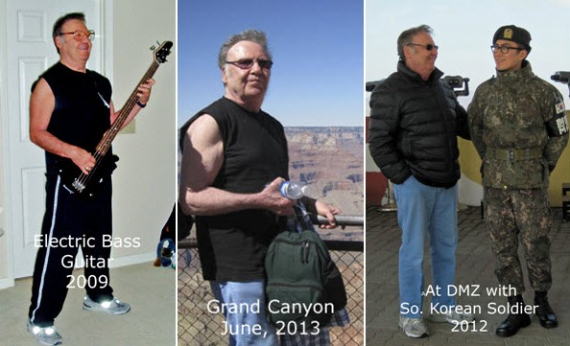

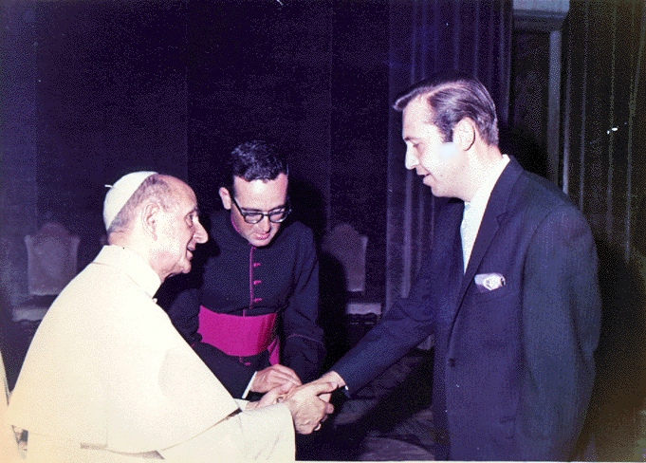
Private Audience with Pope Paul VI, 6/24/70

