TAAA Souvenir Booklet
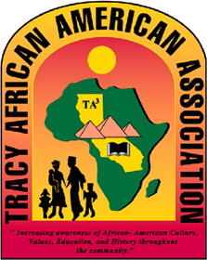
23rd Annual Juneteenth Celebration
June 3, 2017 10 am – 5 pm
Lincoln Park

“FROM OUR ROOTS COME GREATNESS”

Thank you for placing an advertisement in our 2017 TAAA Juneteenth Festival Souvenir Booklet. Your ad will help fund the Wayne Nelson Scholarship Program while giving our community the opportunity to know more about your company. Please complete the form below and submit your artwork, ad copy to yokids3@sbcglobal.net or mail a hard copy along with your payment by Wednesday, May 10, 2017. Please make payment payable to Tracy African American Association, and mail to TAAA Juneteenth Committee, P.O. Box 62, Tracy, CA 95378.

Contact Name ____________________________________________________________

Business Name ___________________________________________________________

Address _________________________________________________________________

City/St/Zip _______________________________________________________________

_____ Business Card Size (Front) $15

_____ Business Card Size (Front and Back) $25

_____ ¼ Page $45

_____ ½ Page $75

_____ Full Page $100

For additional information, please contact (510) 589-6445 or email yokids3@sbcglobal.net. Thank you in advance for your contributions to the education of the next generation.

Sincerely,

/s/ Yolande Barial Knight
2017 Juneteenth Festival Chairperson
TAAA Vice President

