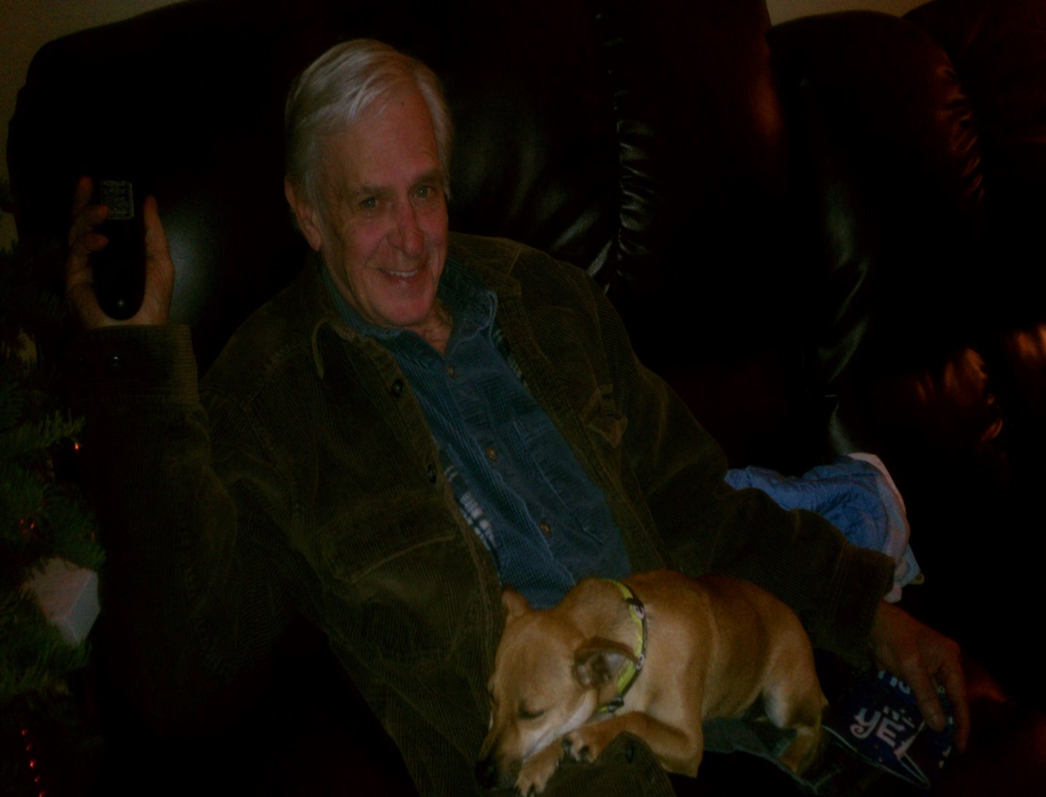

MEMORIAL
FOR
RONALD WAYNE KENNEY
To be held on
SATURDAY, JULY 19, 2014
10:00a.m.
at
Clayton Kay-Vaughn Funeral Home
200 E. Patton Ave., Alvarado, Tx. 76009
Kelvin Hamilton will be conducting the service.
His children and I invite you all to come celebrate Ronnie’s Life with us.

