James “Jim” Carroll May – December 9, 2013
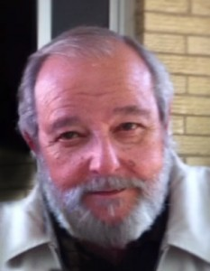
James “Jim” Carroll May, 69, of Amarillo, died Monday, Dec. 9, 2013, in Arlington.
Memorial services will be at 10:00 a.m., Friday, Dec. 13, 2013, in Boxwell Brothers Ivy Chapel with Ricky Griffith of Trinity Fellowship officiating. Arrangements are by Boxwell Brothers Funeral Directors, 2800 Paramount Blvd.
Jim was born April 27, 1944, in Amarillo, to Cyril and Ethel May. He attended Price College Catholic High School, graduated 1962. He graduated with a Bachelors Degree in Psychology from Texas Tech University in 1966. Jim married Dana Dean Hoving on Dec. 23, 1966 at St. Mary’s Catholic Church in Amarillo.
He was preceded in death by Cyril and Ethel May.
Survivors include a brother, CDR Cyril V. May Jr., USN “Ree”; his wife, Dana Hoving May; three sons, James Carroll May, Jentry Collin May, and Jeb Coble May; a daughter, Amanda May Melendez; and nine grandchildren that were the light in his life, Jace Austen May, Zane Ashton May, Carson Rylee May, Logan Maddox May, Ella May Wulfman, Jax Ethan May, Caylee Grace May, Charlee Ann May, and Coble Deen May, lovingly known to them as “Punkin” & “Grand-Pop”.

